
PRODUCT BULLETIN
MODEL SREM SUMP PUMPS
Bulletin 320SREM
Edition 4d

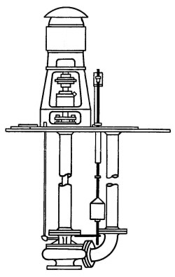
OVER 130 YEARS
PRODUCT BULLETINMUNICIPALCOMMERCIALINDUSTRIAL
MODEL SREM SUMPSump, Lift Stations, Transfer,Condensate Recovery, Breweries,Spill Containment, Processing,
Filter Backwash, Supply WaterDrainage, Contact WaterLeachate Recovery, Bilge

American-Marsh Model SREM Sump Pumps are used in a variety of industries. These rugged and efficient centrifugal pumps are designed for long life and low operational costs. American-Marsh has been building pumps for over 130 years. This long experience is responsible for the superior performance of the Model SREM Sump Pumps.

Material Specifications
PART | CONSTRUCTION
PART | STANDARD FITTED | BRONZE FITTED | NI-RESIST FITTED | 316SS FITTED
Casing | Cast Iron | Cast Iron | Cast Iron | Cast Iron
Impeller | Cast Iron | Bronze | Ni-Resist | 316 Stainless Steel
Pump Shaft | 416 Stainless Steel | 416 Stainless Steel | 416 Stainless Steel | 316 Stainless Steel
Stuffing Box Gland | Cast Iron | Cast Iron | Cast Iron | 316 Stainless Steel
Inboard Head | Cast Iron | Cast Iron | Cast Iron | Cast Iron
Bearing Cap | Cast Iron | Cast Iron | Cast Iron | Cast Iron
Bolts, Studs & Nuts | Steel | Steel | Steel | Steel
Support Pipe and Discharge Pipe | Steel | Steel | Steel | Steel
MODEL SREM SPECIFICATIONS

Casing: The casing is constructed of high tensile cast iron or other specified material. It is of the volute type, carefully and accurately proportioned to permit smooth flow and to convert high velocity energy of the fluid as it leaves the impeller into pressure. Suction and discharge nozzles are casted integral with the volute and are of 250 psi dimensions. All SREF models feature a 250 psi case working pressure. The casing has cast integral feet standard and the discharge port is of the vertical centerline type. Necessary vent and drain openings are provided.

Impeller: The impeller is of the end suction type, casted in one piece of bronze or other specified material. All impellers are hydraulically and dynamically balanced prior to assembly and all impellers have pump out vanes standard on the back side of the imepller to reduce material from building up near the stuffing box.

Case Wear Ring: Standard enclosed impellers are designed with integral case wear rings accurately turned to provide close running fits in casing. The diameters of these rings are such as to reduce end thrust to a minimum. On larger models a rear case wear ring is provided for additional wear resistance.

Inboard Head: The inboard head is constructed of cast iron or other specified material. The inboard head connects the fluid end to the support pipe and contains the inboard head bushing.

Shaft: The shaft is of 416 stainless steel, polished and of large diameter to prevent vibration. Lineshaft bearings are spaced to minimize shaft deflection. The shaft is supported by the thrust bearing housing, located at the surface plate, which has integral lateral adjustment.

Support & Discharge Pipe: The support pipe is of black iron, one end flanged to the inboard head and the other end flanges to the sump cover. Intermediate bearings will be flanged between multiple pieces of support column and spaced accordingly. The discharge pipe is flanged, one end connected to the discharge elbow and the other to the system piping.

Discharge Elbow: The discharge elbow is of high tensile cast iron or of other specified material and of the long radius type flanged to the discharge of the casing and to the discharge pipe assembly.

Sump Cover: The sump cover is of carbon steel, teardrop or of other shape as desired. The sump cover supports the entire weight of the complete pump assembly.

Bulletin 320SREM
Edition 4d

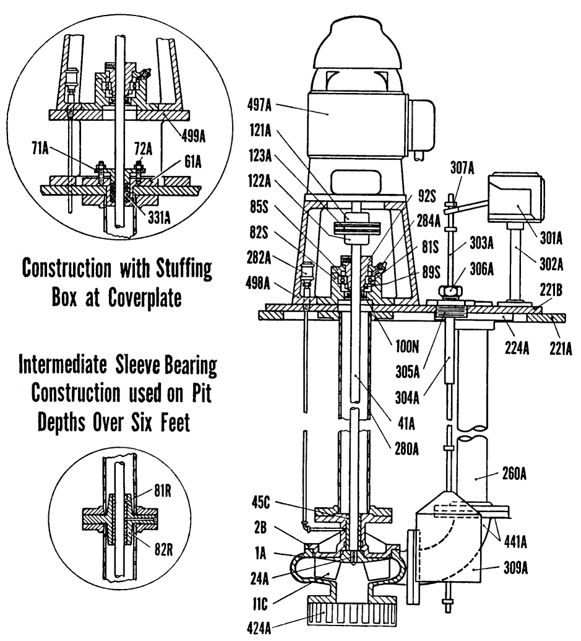
SREM Sectional Drawing

Item Number | Item Description | Num. Req. |  | Item Number | Item Description | Num. Req.
1A | Casing | 1 |  | 221B | Plate, Sump Mounting | 1
2B | Head, Upper Casing | 1 |  | 224A | Flange, Upper Discharge | 1
11C | Impeller | 1 |  | 260A | Pipe, Discharge, Assembly | Varies
24A | Key, Impeller | 1 |  | 280A | Pipe, Support, Assembly | Varies
41A | Shaft, Pump | 1 |  | 282A | Oiler | Varies
45C | Bearing, Casing Head | 1 |  | 284A | Fitting, Zerk Grease | 1
61A | Box, Stuffing | 1 |  | 301A** | Switch, Float | 1
71A | Gland, Stuffing Box | 1 |  | 302A | Bracket, Float Switch | 1
72A | Stud, Gland, with Nut | 2 |  | 303A | Rod, Float | 1
81R | Bearing, Intermediate | Varies |  | 304A | Guide, Float Rod | 1
81S | Bearing, Ball Thrust | 1 |  | 305A | Box, Float Rod Stuffing | 1
82R | Housing, Intermediate Bearing | Varies |  | 306A | Gland Nut, Float Rod Box | 1
82S | Housing, Ball Bearing | 1 |  | 307A | Stop, Float Rod | 4
85S | Cap, Bearing Housing | 1 |  | 309A | Float | 1
89S | Locknut, Ball Bearing | 1 |  | 331A | Packing, Stuffing Box | 1 set
91S* | Lockwasher, Ball Bearing | 1 |  | 332A* | Packing, Float Rod Box | 1 set
92S | Adapter, Ball Bearing | 1 |  | 424A | Strainer, Suction | 1
100N | Ring, Lube Seal | 1 |  | 441A | Elbow, Discharge | 1
121A | Coupling, Motor | 1 |  | 497A** | Motor | 1
122A | Coupling, Pump | 1 |  | 498A | Pedestal, Motor | 1
123A | Disc, Coupling | 1 |  | 499A | Pedestal, Extension | 1
221A | Plate, Sump Cover | 1
* Not Shown in sectional
** Not supplied as standard but can be ordered as an option.
Recommended spare parts are in BOLD.

